PL/SQL Programming

Schema to be Created
CREATE TABLE Customers (
CustomerID NUMBER PRIMARY KEY,
Name VARCHAR2(100),
DOB DATE,
Balance NUMBER,
LastModified DATE
);

CREATE TABLE Accounts (
AccountID NUMBER PRIMARY KEY,
CustomerID NUMBER,
AccountType VARCHAR2(20),
Balance NUMBER,
LastModified DATE,
FOREIGN KEY (CustomerID) REFERENCES Customers(CustomerID)
);

CREATE TABLE Transactions (
TransactionID NUMBER PRIMARY KEY,
AccountID NUMBER,
TransactionDate DATE,
Amount NUMBER,
TransactionType VARCHAR2(10),
FOREIGN KEY (AccountID) REFERENCES Accounts(AccountID)
);

CREATE TABLE Loans (
LoanID NUMBER PRIMARY KEY,
CustomerID NUMBER,
LoanAmount NUMBER,
InterestRate NUMBER,
StartDate DATE,
EndDate DATE,
FOREIGN KEY (CustomerID) REFERENCES Customers(CustomerID)
);

CREATE TABLE Employees (
EmployeeID NUMBER PRIMARY KEY,
Name VARCHAR2(100),
Position VARCHAR2(50),
Salary NUMBER,
Department VARCHAR2(50),
HireDate DATE
);

Example Scripts for Sample Data Insertion

INSERT INTO Customers (CustomerID, Name, DOB, Balance, LastModified)
VALUES (1, 'John Doe', TO_DATE('1985-05-15', 'YYYY-MM-DD'), 1000, SYSDATE);

INSERT INTO Customers (CustomerID, Name, DOB, Balance, LastModified)
VALUES (2, 'Jane Smith', TO_DATE('1990-07-20', 'YYYY-MM-DD'), 1500, SYSDATE);

INSERT INTO Accounts (AccountID, CustomerID, AccountType, Balance, LastModified)
VALUES (1, 1, 'Savings', 1000, SYSDATE);

INSERT INTO Accounts (AccountID, CustomerID, AccountType, Balance, LastModified)
VALUES (2, 2, 'Checking', 1500, SYSDATE);

INSERT INTO Transactions (TransactionID, AccountID, TransactionDate, Amount, TransactionType)
VALUES (1, 1, SYSDATE, 200, 'Deposit');

INSERT INTO Transactions (TransactionID, AccountID, TransactionDate, Amount, TransactionType)
VALUES (2, 2, SYSDATE, 300, 'Withdrawal');

INSERT INTO Loans (LoanID, CustomerID, LoanAmount, InterestRate, StartDate, EndDate)
VALUES (1, 1, 5000, 5, SYSDATE, ADD_MONTHS(SYSDATE, 60));

INSERT INTO Employees (EmployeeID, Name, Position, Salary, Department, HireDate)
VALUES (1, 'Alice Johnson', 'Manager', 70000, 'HR', TO_DATE('2015-06-15', 'YYYY-MM-DD'));

INSERT INTO Employees (EmployeeID, Name, Position, Salary, Department, HireDate)
VALUES (2, 'Bob Brown', 'Developer', 60000, 'IT', TO_DATE('2017-03-20', 'YYYY-MM-DD'));

Exercise 1: Control Structures

Scenario 1:

Code:
BEGIN
for cust IN (SELECT c.CustomerID, c.DOB, l.LoanID, l.InterestRate
FROM Customers c
JOIN Loans l ON c.CustomerID = l.CustomerID) LOOP
IF months_between(sysdate, cust.DOB) / 12 > 60 THEN
UPDATE Loans
SET InterestRate = InterestRate - 1
WHERE LoanID = cust.LoanID;
END IF;
END LOOP;
dbms_output.put_line('Discount applied for eligible senior customers.');
END;
/

Output:
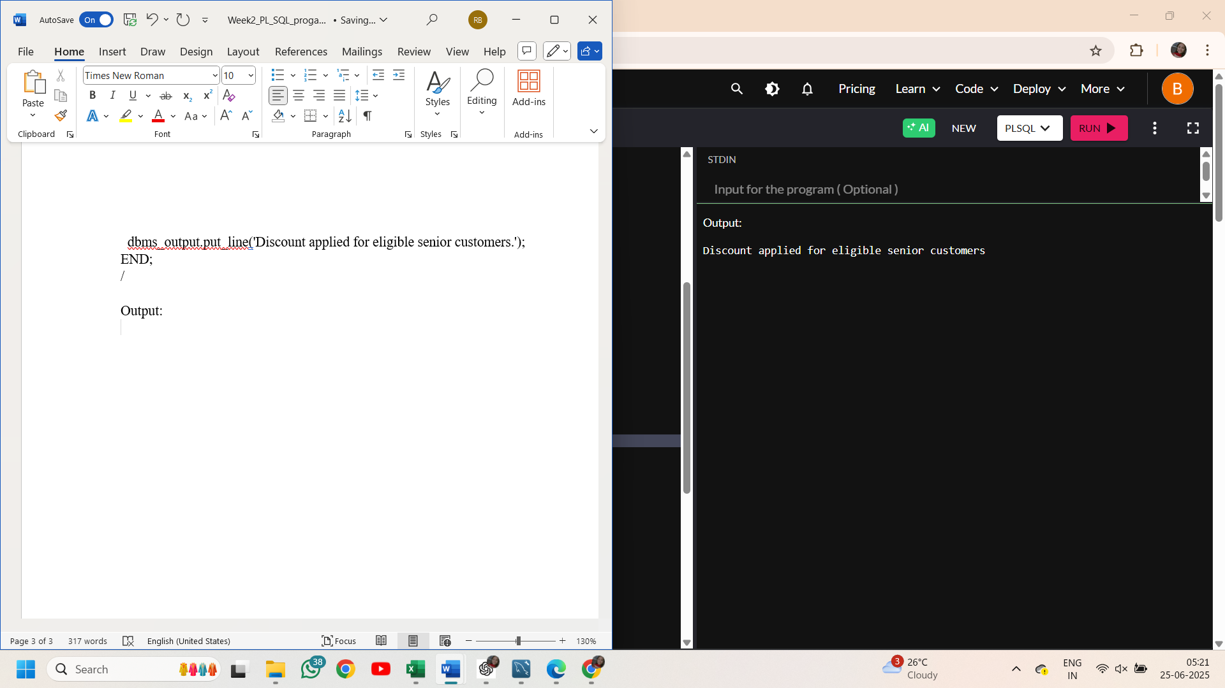

Scenario 2:

Code:
DECLARE
IsVIP boolean;
BEGIN
for cust in (select CustomerID,Name,Balance from Customers) loop
if cust.Balance>10000 then
IsVIP:=true;
else
IsVIP:=false;
end if;
if IsVIP then
dbms_output.put_line('customer '||cust.Name||' with ID'|| cust.CustomerID||'is a vip');
else
dbms_output.put_line('customer '||cust.Name||' with ID'|| cust.CustomerID||' is not a vip');
end if;
end loop;
END;
/

Output:
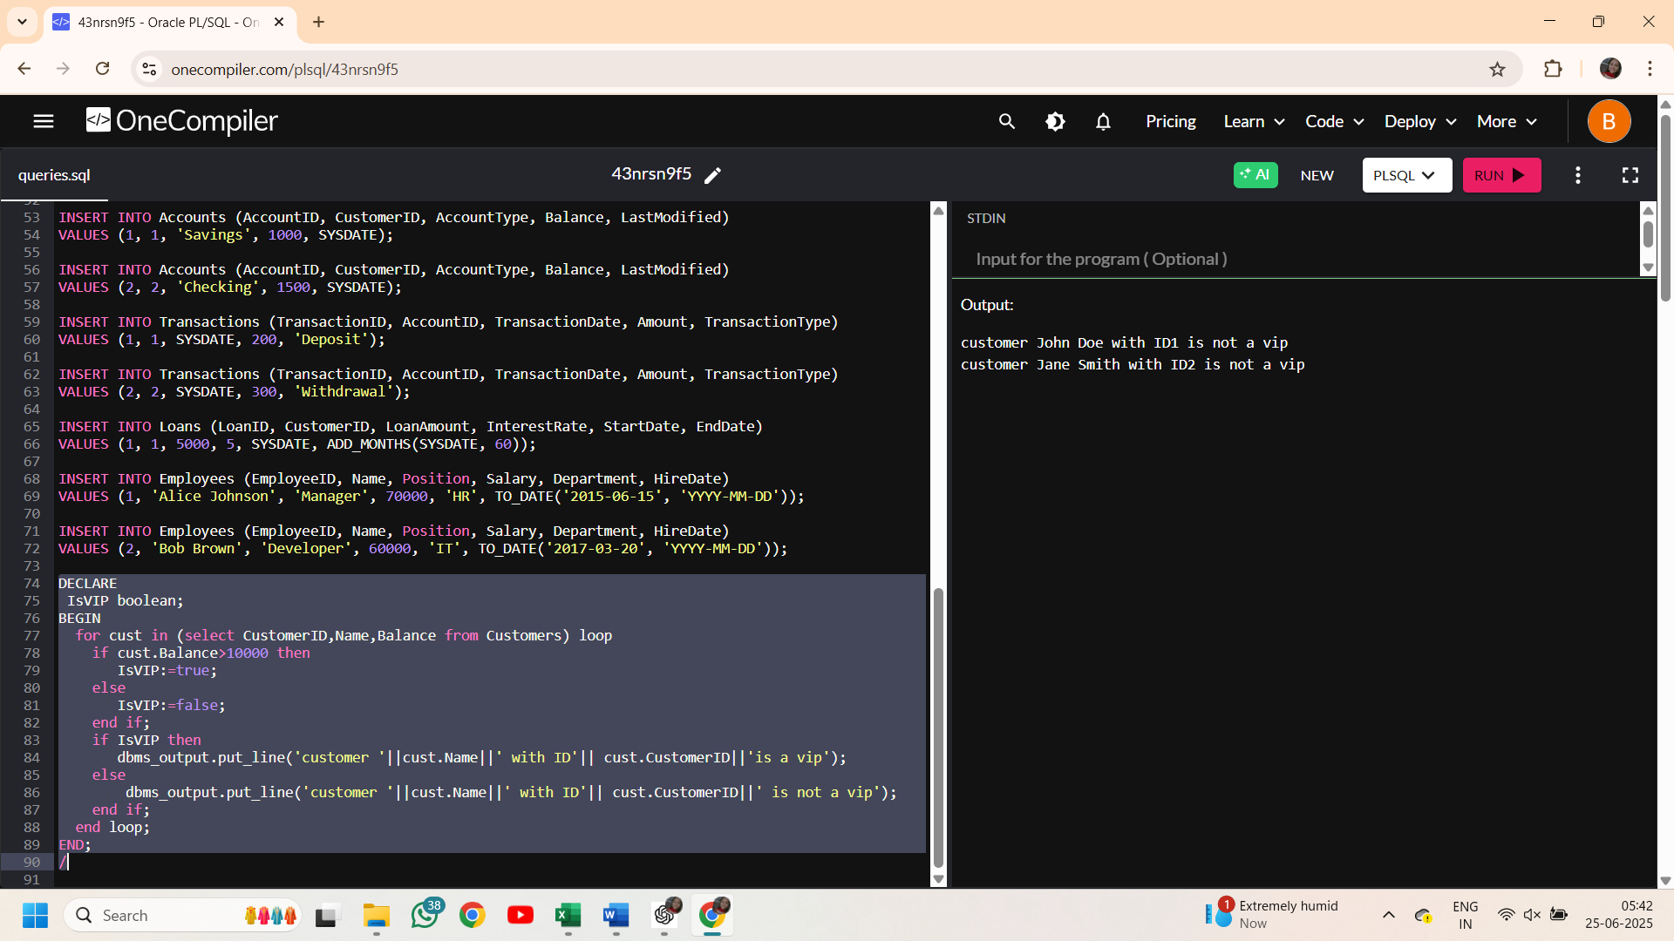

Scenario 3:

Code:
BEGIN
for loan in(select l.LoanID,l.CustomerID as loanCustID,l.EndDate,c.Name,c.CustomerID as custID
from Loans l join Customers c on
l.CustomerID=c.CustomerID
where l.EndDate between ADD_MONTHS(SYSDATE, 60) and ADD_MONTHS(SYSDATE,61))
loop
dbms_output.put_line('Reminder: customer '||loan.name||' with id'|| loan.loanCustID||' is due on'||to_char(loan.EndDate,'YYYY-MM-DD'));
end loop;
END;
/

Output:
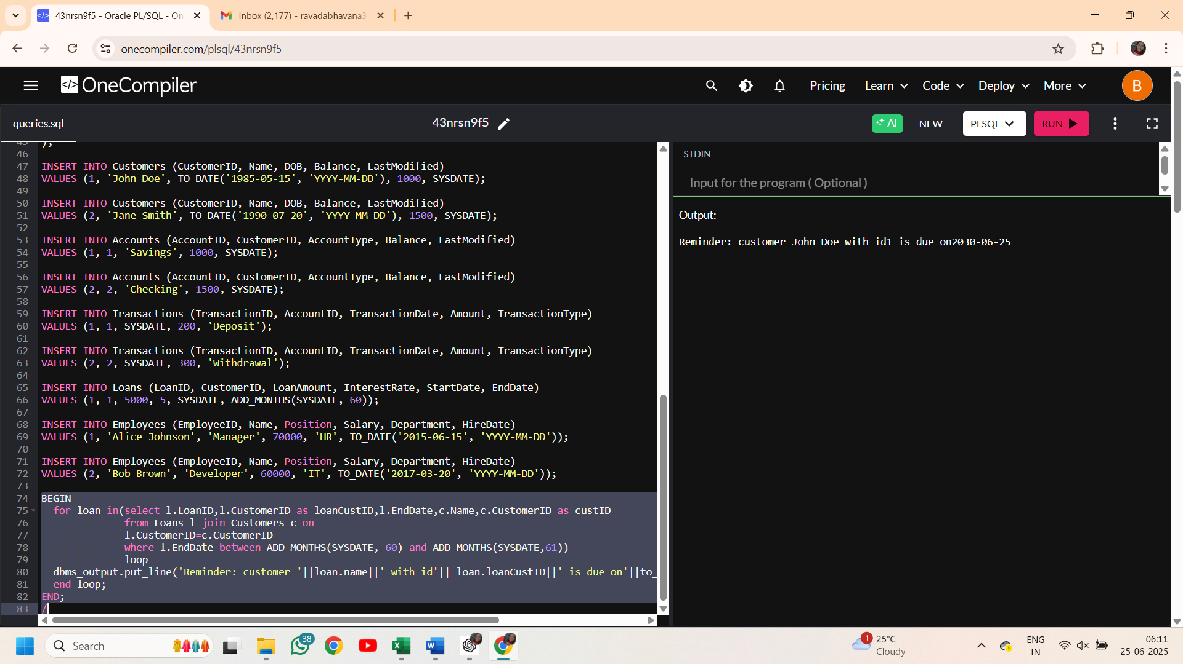

Exercise 3: Stored Procedures

Scenario 1:

Code:
create or replace procedure ProcessMonthlyInterest as
account_count NUMBER:=0;
BEGIN
update Accounts
set Balance=Balance+(Balance*0.01),LastModified=SYSDATE
where AccountType='Savings';
account_count:=SQL%rowcount;
dbms_output.put_line(account_count||' accounts have been updated with 1% interest');
commit;
END;
/
exec ProcessMonthlyInterest;

Output:
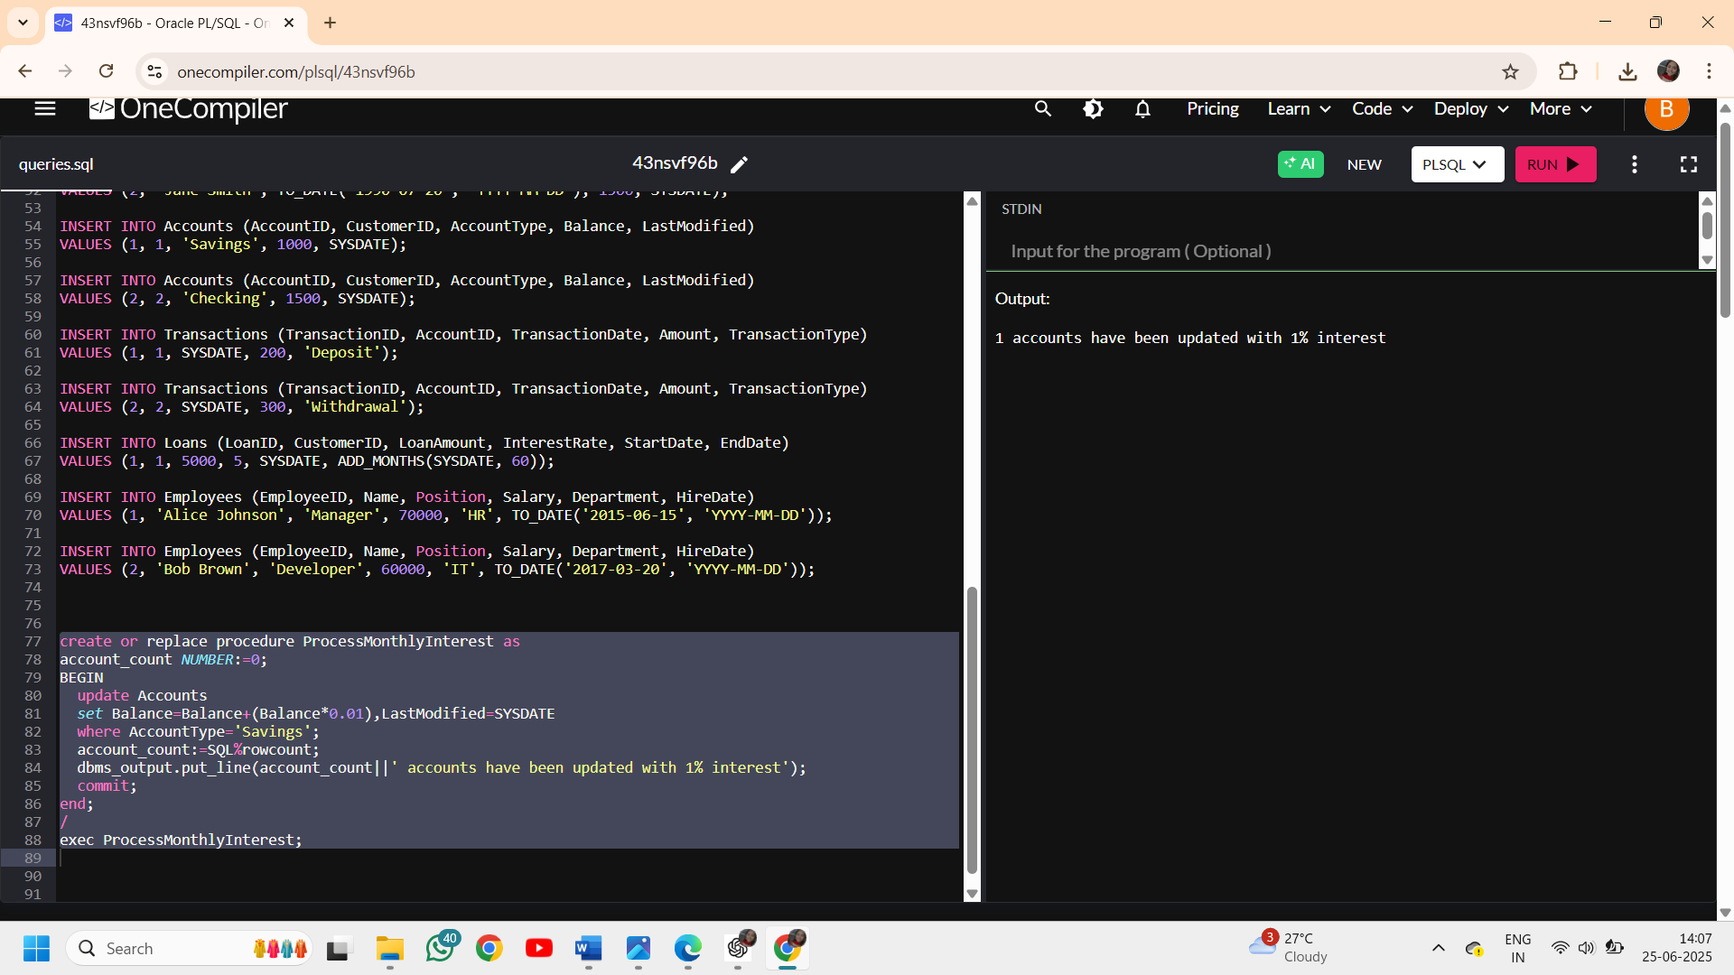

Scenario 2:
create or replace procedure UpdateEmployeeBonus(
v_department varchar2,
v_bonuspercentage number)
as
v_count number:=0;
BEGIN
update Employees
set salary=salary+(salary*v_bonuspercentage/100)
where Department=v_department;
v_count:=SQL%rowcount;
dbms_output.put_line(v_count||' employees from '||v_department||' department got a bonus of '||v_bonuspercentage||'%');
commit;
END;
/
exec UpdateEmployeeBonus('IT',8);

Output:
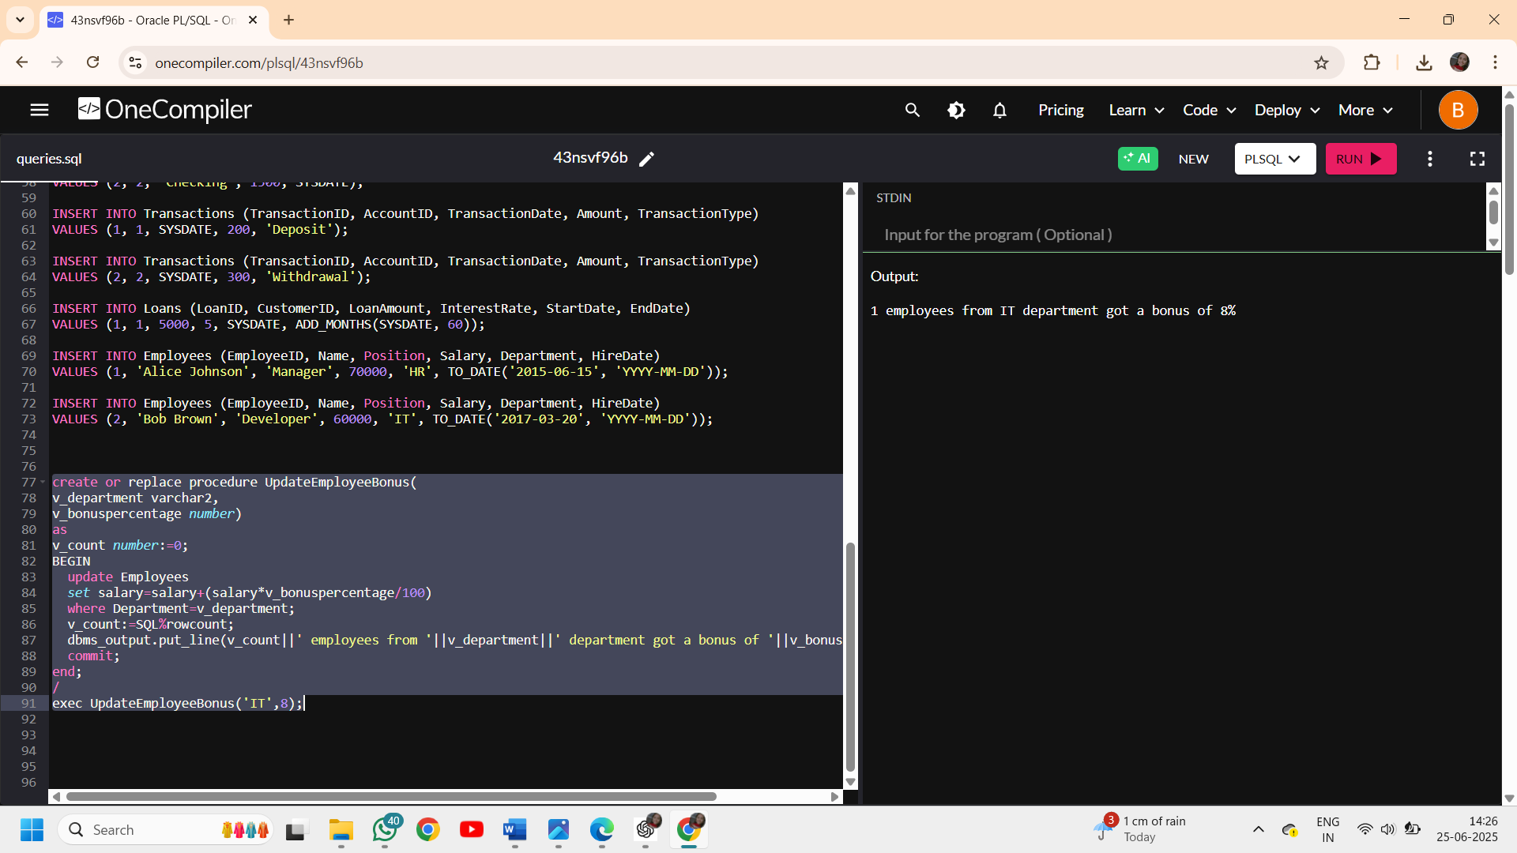

Scenario 3:

Code:
create sequence Transaction_seq start with 1000 increment by 1;
create or replace procedure TransferFunds(
p_FromAccountId number,
p_ToAccountId number,
p_amount number) as
p_bal number;
BEGIN
if p_FromAccountId=p_ToAccountId then
raise_application_error(-20002,'self transfer is not possible');
end if;
select Balance into p_bal from Accounts
where AccountID=p_FromAccountId;
if p_bal<p_amount then
raise_application_error(-20001,'sorry! insufficient balance in the source account');
end if;
update Accounts
set Balance=Balance-p_amount,
LastModified=SYSDATE
where AccountID=p_FromAccountId;
update Accounts
set Balance=Balance+p_amount,
LastModified=SYSDATE
where AccountID=p_ToAccountId;
INSERT into Transactions(TransactionID, AccountID, TransactionDate, Amount, TransactionType)
values (Transaction_seq.NEXTVAL,p_FromAccountId,SYSDATE,p_amount,'Withdrawal');
INSERT into Transactions(TransactionID, AccountID, TransactionDate, Amount, TransactionType)
values(Transaction_seq.NEXTVAL,p_ToAccountId,SYSDATE,p_amount,'Deposit');
dbms_output.put_line(p_amount||' has been tranferred to account with id '|| p_ToAccountId);
commit;
END;
/
exec TransferFunds(1,2,300);

Output:
